**COMMUNICATIONS TOOLKIT**

*Launch the Corporate Traveler Cost Savings Program with the email templates, social messaging, and graphics in this toolkit.*

**About the BIO/Corporate Traveler Partnership**

The Biotechnology Innovation Organization (BIO) and Corporate Traveler teamed up to provide BIO and state affiliate members with streamlined travel management solutions. This strategic offering will provide members with access to dedicated travel support focused on expense management solutions, 24/7 support, access to discounted rates and more, ensuring seamless, cost-effective travel experiences.

**Corporate Traveler Member Benefits**

Member companies gain access to a full-service global travel management company, including:

* Tailored travel program setup – No start up fees. We help build a customized travel management program tailored to their business, including:
  + Easy-to-use travel platform
  + 24/7 support from dedicated travel consultants
  + Access to exclusive negotiated rates on airfare, hotels, and rental cars
  + Custom-built travel policies to streamline approvals and compliance
* Dedicated travel manager for personalized service and support
* Waived line of credit when booking on account, providing flexibility and streamlined payments
* Discounted management fees, plus a $500 travel voucher for qualifying accounts based on travel spend
* Real-time financial reporting, duty of care tracking, and environmental sustainability analytics to help manage costs, compliance, and traveler safety
* Industry expertise in life sciences, including advisory boards, leadership meetings, clinical trial, Sunshine Act/HIPAA and GCP Compliance

**Website Content**

[Suggested content for affiliate website]

**About Corporate Traveler**

Corporate Traveler has been providing travel management solutions for over 30 years. Our unique service model blends dedicated travel managers and user-friendly travel technology. We specialize in creating tailored solutions for startups and small to medium-sized enterprises, saving them time, money, and providing peace of mind. Our 24/7 support, exclusive deals, and personalized service make business travel simpler, faster, and more effective.

**Member Benefits**

Member companies gain access to a full-service global travel management company, designed to optimize your business travel experience. Enjoy exclusive benefits, including:

* **Tailored travel program setup – No start up fees.** We help you build a customized travel management program tailored to your business, including:
  + Easy-to-use travel platform
  + 24/7 support from dedicated travel consultants
  + Access to exclusive negotiated rates on airfare, hotels, and rental cars
  + Custom-built travel policies to streamline approvals and compliance
* Dedicated travel manager for personalized service and support
* Waived line of credit when booking on account, providing flexibility and streamlined payments
* Discounted management fees, plus a **$500 travel voucher** for qualifying accounts based on travel spend
* Real-time financial reporting, duty of care tracking, and environmental sustainability analytics to help manage costs, compliance, and traveler safety
* Industry expertise in life sciences, including advisory boards, leadership meetings, clinical trial, Sunshine Act/HIPAA and GCP Compliance

**GET STARTED button** [link to <https://www.bio.org/save/inquiry-form-corporate-traveler> or where appropriate for your organization]

Optional video link to add or embed in website - <https://youtu.be/Nza122g2Auw>

**Announcement to Member Companies**

[Suggested content for newsletter and/or other member communications]

**New Savings Program: [AFFILIATE NAME] & Corporate Traveler**

**Subject: Introducing Corporate Traveler: [AFFILIATE NAME]’s** **New Travel Partner**

**[AFFILIATE NAME]** is proud to partner with **Corporate Traveler** as our **preferred travel management provider**, offering members exclusive perks to simplify business travel and drive cost savings.

Through our cost savings program, Corporate Traveler provides a **high-touch service model** backed by intuitive technology, ensuring biotech companies can optimize their travel programs while staying focused on groundbreaking research.

Whether you're managing **complex itineraries, clinical trials, or essential business travel**, Corporate Traveler delivers:

✅ Expert travel support with 24/7 assistance  
✅ Exclusive negotiated rates on airfare, hotels, and rental cars

✅ A seamless, easy-to-use booking platform  
✅ Tailored travel policies to streamline approvals and compliance

As a member company, your organization gains access to a **customized travel management program with no startup fees**—designed to help you travel smarter, reduce costs, and maximize efficiency.

**Start optimizing your travel program today.** Contact us to get started. [link to <https://www.bio.org/save/corporate-traveler> or where appropriate for your organization]

[Insert Corporate Traveler logo, which can be downloaded from ShareVault]

**Social Media Announcement**

At **[STATE AFFILIATE NAME],** we're shaping the future of life sciences, and our new partnership with @**Corporate Traveler** is a total game changer! With our member companies leading groundbreaking research, streamlining travel is more important than ever.

**Corporate Traveler’s** tailored, high-touch travel management services help BIO members:

✅ Save time with expert travel support and 24/7 assistance  
✅ Reduce costs with exclusive discounts on flights, hotels, and car rentals  
✅ Simplify travel with a custom platform and policy management  
✅ Focus on innovation—not travel disruptions

With this partnership, we’re making it easier for members to invest in science while Corporate Traveler takes care of the journey.

Explore exclusive member benefits: [Insert <https://www.bio.org/save/corporate-traveler> or Corporate Traveler’s page on your website]

#biotechnology #BIO #lifesciences #costsavings

[Carousel layout graphics below can be found in ShareVault/[State Affiliate Resources Page](https://www.bio.org/save/bbs-affiliates)]

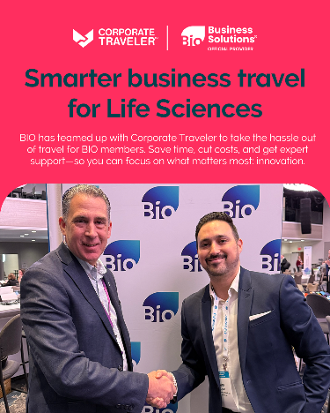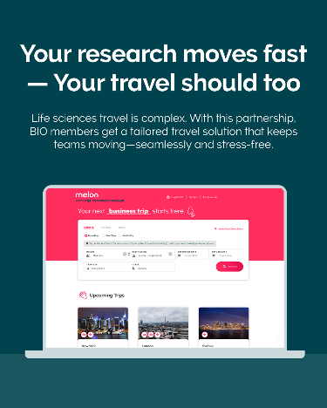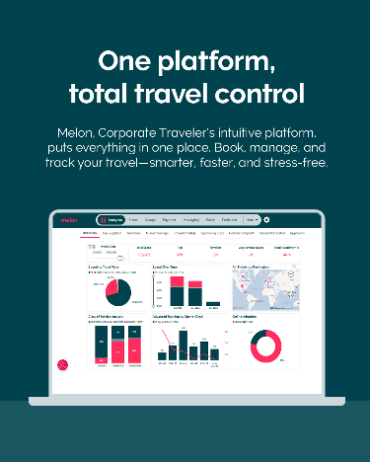



**Contact Information**

**Business Development Inquires:** [save@bio.org](mailto:save@bio.org), BIO Business Development rep, and Dan Lauer, [Daniel.lauer@flightcentre.ca](mailto:Daniel.lauer@flightcentre.ca)

**Corporate Traveler:** Dan Lauer, USA Partnerships Manager, [Daniel.lauer@flightcentre.ca](mailto:Daniel.lauer@flightcentre.ca)