
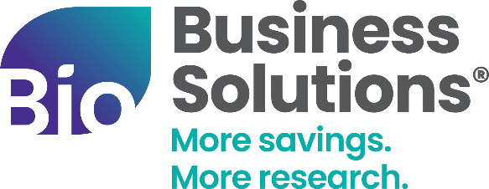

COMMUNICATIONS TOOLKIT
Launch the SU Group Cost Savings Program with the email templates, social messaging, and graphics in this toolkit.

About the BIO/SU Group Partnership
The Biotechnology Innovation Organization (BIO) and the Specialty Underwriters Group (SU Group) teamed up to provide BIO and state affiliate members a customized equipment maintenance solution. SU Group consolidates multiple equipment service contracts into one easily manageable agreement that reduces costs and offers flexibility and continuity.
SU Group Member Benefits
- 15-30% off eligible equipment service agreements and/or maintenance contracts
- Dedicated sales team specifically focused on life science companies
Website Content
[Suggested content for affiliate website]
About Specialty Underwriters
SU’s customized equipment maintenance solution consolidates multiple equipment service contracts to one easily manageable agreement that reduces costs and offers flexibility and continuity while including parts, labor and travel costs associated with emergency and preventative maintenance visits.
Member Benefits
- 15-30% off eligible equipment service agreements and/or maintenance contracts
- Dedicated sales team specifically focused on life science companies
What to Expect with SU Group

Cost Savings
- Guaranteed discounts
- Financially capped budget
- In-house reimbursement
- Consolidated billing
Consolidation
- TELESERVE dispatch
- One point of contact
- Asset management
- Reduction of purchase orders
Convenience
- Ease of use
- PM monitoring notifications, and reminders
- Loaner coverage
- Warranty watch
Control
- Vendor of choice
- Comprehensive coverage
- Add/remove equipment
- Reporting

GET STARTED button [link to https://www.bio.org/save/inquiry-form-su-group or where appropriate for your organization]
Optional video link to add or embed in website - https://vimeo.com/1056906654

Announcement to Member Companies
[Suggested content for newsletter and/or other member communications]
New Savings Program: [AFFILIATE NAME] & SU Group
[AFFILIATE NAME] is eager to launch a new cost savings program with SU Group, designed to help life science companies cut lab equipment service costs and streamline contract management.
SU Group consolidates multiple service agreements into one flexible, cost-effective solution, covering parts, labor, and travel for emergency and preventive maintenance. Plus, [AFFILIATE NAME] members benefit from dedicated support, reduction of purchase orders, and comprehensive coverage.
Take the hassle out of equipment maintenance and keep your lab running smoothly. Learn more here [Insert https://www.bio.org/save/su-group or SU Group’s page on your website]
[Insert SU Group logo, which can be downloaded from ShareVault]

Social Media Announcement
We are excited to partner with SU Group to help our member companies reduce lab equipment service costs and simplify contract management. With exclusive member savings on equipment service agreements, this program ensures cost control, convenience, and flexibility—all while keeping your lab running smoothly.
✅ Consolidate multiple service contracts into one
✅ Enjoy guaranteed discounts & financial caps
✅ Streamline maintenance with proactive monitoring
Take control of your lab operations and budget with this new cost savings program. Learn more today – [Insert https://www.bio.org/save/su-group or SU Group’s page on your website]
[insert launch social graphic]
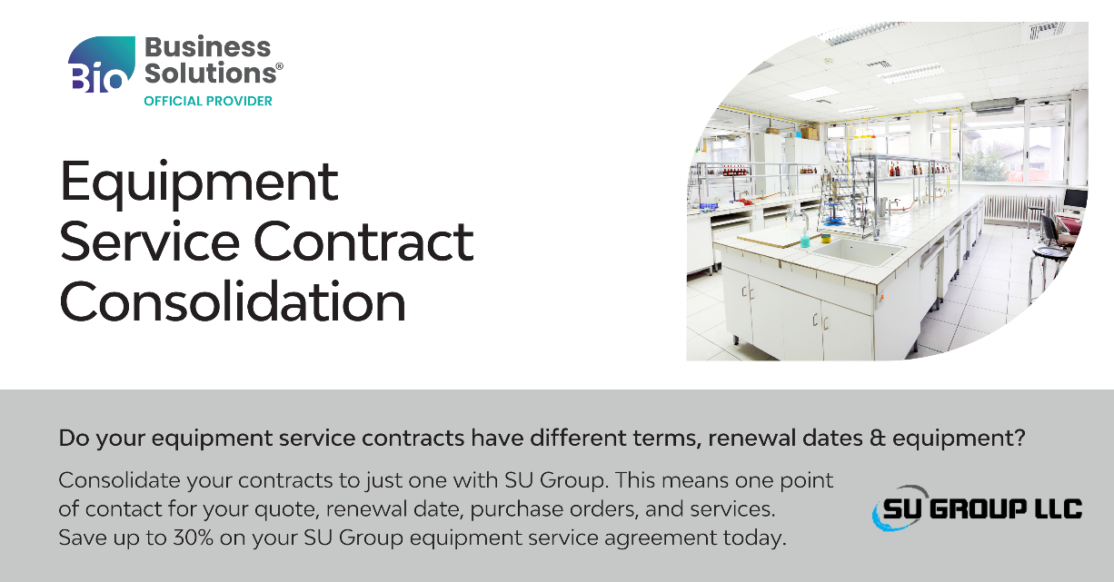
Contact Information
Business Development Inquires: save@bio.org, BIO Business Development rep, and Ric Kunnert, RKunnert@su-group.com
SU Group: Ric Kunnert, Regional Sales Manager, RKunnert@su-group.com

