Employee Business Resource Groups (EBRGs)
When you formalize your professional relationship with employees who share common cultural interests by joining an EBRG, we recognize the strategic value and impact to business results that are possible.​ ​Participation in an EBRG benefits you and our company.
EBRGs at a Glance
EBRGs present an opportunity for you to:
- Align with the Global Diversity and Inclusion (GD&I) Global Priorities
- Business Integration/Insights and Talent Management
- Learn about the unique culture, background and experience of other colleagues
- Provide diversity insights to the Company's operating divisions and staff functions
- Foster leadership effectiveness
- Support critical business functions
- Participation in EBRGs offers opportunities for individual growth and development, while fostering higher productivity and engagement.

EBRGs provide an important platform for you to contribute to business results. You can share intuitive insights about the affinity populations you represent. You can work in collaboration with the respective Employee Business Resource Group (EBRG) to support business objectives related business integration/insights and Talent. All this makes EBRGs a vital source of the organization’s competitive advantage.

Roles of the EBRG’s:

- Drive the message of global diversity and inclusion throughout Merck and MSD through the implementation of our GD&I key initiatives
- Provide insights on critical Human Resources strategies, policies and procedures to ensure success across our broad diverse employee base
- Provide insights and feedback on key business strategies and initiatives to create a competitive advantage for the company
- Talent Management – Participate in capability building sessions to create the next generation of diverse leaders
- Optimize the impact of the local EBRG Chapters across the globe to enhance our brand in the local communities

Key EBRG Priorities
- Business integration/insights
  - Provide perspective of the business through the experiences of persons from multiple backgrounds, cultures and experiences
  - Offer intuitive knowledge on multi-cultural markets and the growth markets outside of the United States
- Talent Management
  - Ensure professional growth of its members through networking, mentoring and leadership development
  - Foster greater workforce diversity through inclusion and engagement
An employee is welcome to join any employee business resource group(s). The current Employee Business Resources Groups represent a diverse set of interests and affinities, including:
- ​Differently Abled
- Asia Pacific
- Hispanic/Latinos
- Interfaith
- League of Employees of African Descent
- Native American/Indigenous EBRG
- LGBT (Lesbian, Gay, Bisexual and Transgender employees)
- Veteran’s
- Women’s Millennial/Generation Y
How Do You Join an EBRG?

You can join an EBRG by:
- Attending and participating in an upcoming EBRG meeting at your location
- Sign up as a member and provide the appropriate information either on line or in person at an EBRG event
How Do You Start an EBRG Chapter?
- Gather a core group of interested employees, a majority of whom reflect the EBRG’s dimension of diversity
- Obtain advice from the appropriate EBRG Leader
- Obtain approval from the Global Diversity & Inclusion Center of Excellence
- Develop an organizational structure with guidance from the appropriate EBRG Leader
- Become familiar with the roles and responsibilities of being an EBRB Chapter Leader (see Appendix)

Things to Consider When Becoming a Chapter Leader:
- You must have managerial approval to be a Chapter Lead
- Roles and Responsibilities of a ERG Chapter Leader (co-leadership is recommended)
- Work with the EBRG Leader to align local chapter activities with overall objectives of the Network
- Engage and collaborate with other colleagues across our entire ERG organization to drive membership and networking activities
- Become familiar with the Roles and Responsibility of being a ERG Chapter Leader

Next Steps:
- Receive approval from your direct manager
- Seek interest from a Co-Chair
- Contact the EBRG Leader
- Comprehensive market assessment to increase the success of the launch
- Complete and submit the Employee Resource Group Expansion Form and return to EBRG Leader
- Once the ERG form is submitted and the confirmation of the EBRG Leader is in place. Your chapter and your contact information will be loaded online and your membership drive may begin.

Roles of an EBRG Chapter Lead
- Accountable to the EBRG Global Leader
- Meets as a member of the Global EBRG Chapter Community.
  - Support and Leads local Chapter in support of EBRG Priorities (in alignment with GD&I COE)
  - Business Integration/Insights
  - Talent Management
- Attend, support and represent EBRG at local functions held by other EBRG chapters on-site to ensure positive interaction and share best practices.
- Coordinate business-related efforts and source volunteers for Initiatives and site/regional-specific events/initiatives
- Prepare, Coordinate, Oversee and Administer:
  - Local Communication Plans (site/region) any other communications to be coordinated with Communications Lead Volunteer
    - Includes posting all events on the EBRG Sync Community Calendar.
    - Posting twice a month in the EBRG Community in Sync.(if one exists)
  - Local Events/Initiatives
  - Membership Drives
  - Site/Regional Volunteers
- Three local events per year. required (i.e. membership drive, virtual call, community event, greet/meet)

Key Competencies an EBRG Leader

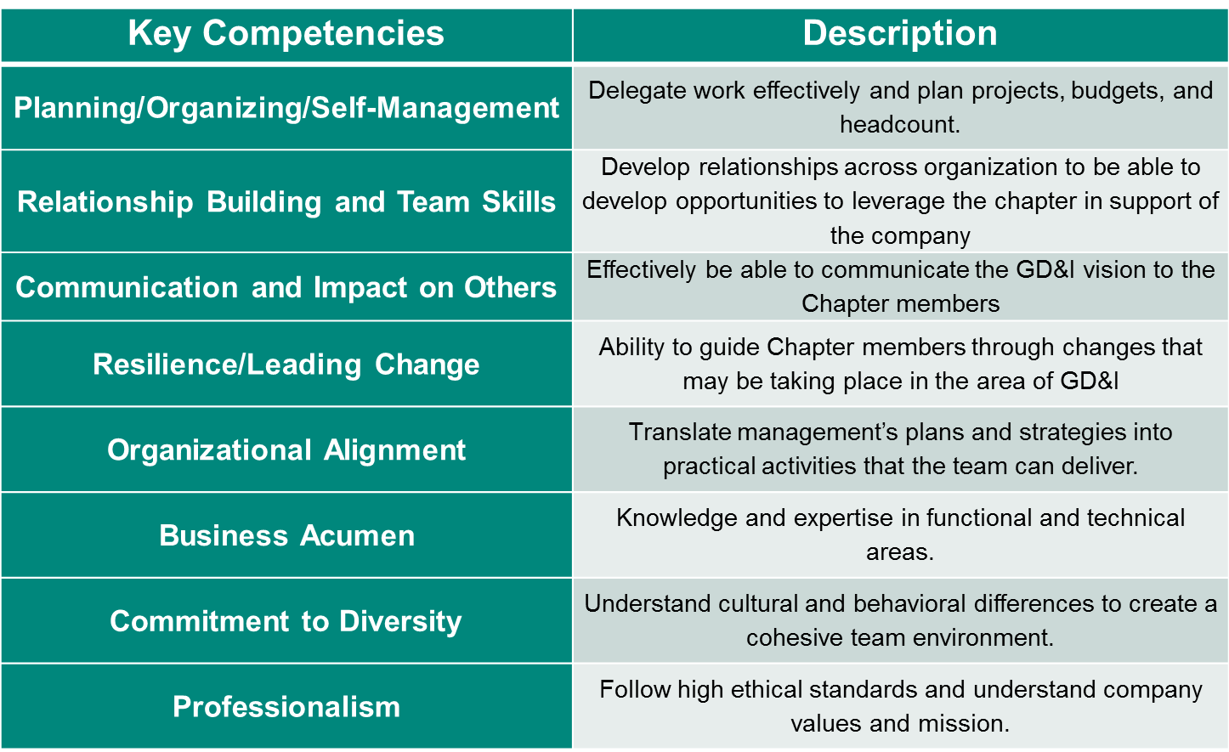

Other external resources:

https://www.hrc.org/resources/establishing-an-employee-resource-group

https://www.energy.gov/diversity/downloads/application-guidelines-chartering-employee-resource-group

https://www.cisco.com/c/dam/en_us/about/ac49/ac55/docs/RESOURCE_GUIDE_external11_2010.pdf

